Vertigo/Dizziness Assessment and Management

What is ‘dizziness’?
- Broadly ‘dizziness’ incorporates four descriptive symptoms: vertigo, light headedness, disequilibrium and pre-syncopal sensations [6].
- ‘Vertigo’ = false sense of self-motion without any motion or the feeling of distorted self-motion with normal movement [6].
- ‘Dizziness’ = sense of disturbed or impaired spatial orientation without a false or distorted sense of motion [6].
- ‘Disequilibrium’ = inability to maintain balance [6].
- ‘Presyncope’ = sense of losing consciousness [6].
- ‘Light headedness’ = vague symptom of feeling disconnected from the environment [6].
- All the above symptoms are common presentations to a ‘Dizzy Assessment Clinic’.
- A Vestibular Physiotherapy Assessment will consider all details of such symptoms.
- The duration of attacks, frequency of attacks, onset, triggers involved, description of symptoms and additional signs (ear and headache) are valuable and aid in ‘hypothesis and impression’ building.

Background:
- Dizziness is among the most common complaint in medicine, affecting approximately 20% to 30% of persons in the general population [1].
- 75% of all presentations are classed as peripheral disorders [1].
- Laboratory testing and imaging are not recommended when no neurologic abnormality is found on examination [1].
- Neurology review is usually not indicated for peripheral disorders.
- A neurology review is usually deemed necessary when there are ‘clinical signs and symptoms’ which indicate a possible central cause (brain/spinal cord) to the dizziness.
- The primary purpose of a Vestibular Physiotherapy Assessment is to assess for possible central signs and symptoms and refer onward to Neurologists/Medical Staff/ENT where need be.

Central versus Peripheral Presentations:
- Central vertigo is a clinical condition in which an individual experiences hallucination of motion of their surroundings, or a sensation of spinning, while remaining still, as a result of dysfunction of the vestibular structures in the central nervous system (CNS) [1].
- Peripheral vertigo may occur as a result of problems in the peripheral vestibular system from the inner ear to the vestibular division of the VIIIth cranial nerve. In other words: dizziness is due to issues in regions NOT within the brain [1].

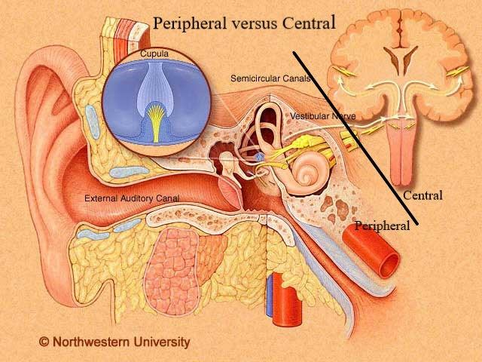

Differential Diagnosis:
- There are many potential causes for dizziness, below are some examples [1]. Vestibular Physiotherapists aim to be knowledgeable in such pathologies and ‘screen’ for these in your assessment.
- During your assessment your Vestibular Physiotherapist will be asking certain questions, performing certain clinical tests and oculomotor/nystagmus examinations. Assessment is performed to build an ‘impression/hypothesis’ of the contributing factors to your condition.

Dizziness/Vertigo/Light Headedness/Disequilibrium

Central Pathology Peripheral Pathology Other
Stroke BPPV Cardiac
Migraine Vestibular Dysfunction Psychological
MS Meniere’s Disease Cardiovascular
Cerebellar Pathologies Cervicogenic

Interesting Information:
- 75% of all dizziness presentations are thought to be peripheral in nature [1].
- Cervicogenic dizziness ‘very rarely’ gives the perception of vertigo, rather ‘light headedness’ is experienced’ [6].
- Cervicogenic dizziness is a diagnosis by exclusion, all other vestibular pathologies/ central causes need to be ‘ruled out’ prior to ‘cervicogenic dizziness diagnosis’ [6].
- There are usually clear signs and symptoms which alert clinicians to potential central causes to your presentation. If such signs or symptoms are noted your Physiotherapist will immediately refer you back to your GP or the Neurologists.
- Often, the contributing factors to your symptoms are multifactorial- E.G Mixed cases of Vestibular Dysfunction with BPPV. Your Vestibular Physiotherapist will address all contributing factors in your presentation and design a suitable individualised management plan to suit.

Clinical Signs and Symptoms Assisting Diagnosis:
- There are known clinical signs (nystagmus, neurological examination findings) and symptom characteristics that will alert your Vestibular Physiotherapist to possible ‘central’ causes to your presentation, if present.
- Vestibular Physiotherapists, using appropriate equipment (infrared goggles), are trained in assessing important involuntary eye movements (nystagmus). Nystagmus interpretation during certain clinical tests can aid in differentiating possible central versus peripheral disorders.
- Assessment of vertigo/dizziness includes ‘very specific’ subjective information and history taking, oculomotor examination, nystagmus examination, neurological examination and cervical (neck) examination. All of which is included in a Vestibular Physiotherapy Assessment performed at Vertigo Physio and Rehab.

Overview of Treatment for Peripheral Disorders:
- Evidence based practice highly recommends Vestibular Rehabilitation programs for Vestibular Peripheral Pathologies. Vestibular Physiotherapists prescribe such individualised programs for your certain pathology [3].
- If Benign Paroxysmal Positional Vertigo (BPPV- crystals in the inner ear) is a contributing factor to the vertigo/dizziness presentation, then certain ‘repositioning techniques’ are required- these are performed by Vestibular Physiotherapists [4].
- If one of your contributing factors is ‘cervicogenic (neck)’ your Physiotherapist will also utilise methods of treatment supported in evidence-based care: sensory retraining, hands on techniques, postural re-correction [6].
- Vestibular Rehabilitation is commonly also part of the treatment recommended for central causes to dizziness [5].
- If there are concerns seen in your assessment which indicate the need for an Ear Nose and Throat Specialist referral, you Vestibular Physiotherapist will ensure this is recommended.

Overview of Treatment for Central Causes:
- If your Vestibular Physiotherapist suspects any central causes to your condition a referral to a Neurologist will be prioritised.
- Once a Neurology review has taken place and appropriate medical management has commenced, commonly you will return to Vestibular Physiotherapy for ongoing rehab [5].

Additional Resources/Patient Information Links:
Vertigo Physio and Rehab website:
https://www.vertigophysioandrehab.com/

Vestibular Disorders Association- Patient Information
https://vestibular.org/educational-resources

Dizziness and Balance Website
https://www.dizziness-and-balance.com/

Recent Literature and Clinical Guidelines Referenced:
1.Muncie Jr, H. L., Sirmans, S. M., & James, E. (2017). Dizziness: approach to evaluation and management. American family physician, 95(3), 154-162.
2. Hall, C. D., Herdman, S. J., Whitney, S. L., Cass, S. P., Clendaniel, R. A., Fife, T. D., ... & Woodhouse, S. N. (2016). Vestibular rehabilitation for peripheral vestibular hypofunction: an evidence-based clinical practice guideline: from the American physical therapy association neurology section. Journal of Neurologic Physical Therapy, 40(2), 124.
3. Whitney, S. L., Alghadir, A. H., & Anwer, S. (2016). Recent evidence about the effectiveness of vestibular rehabilitation. Current treatment options in neurology, 18(3), 13.
4. Bhattacharyya, N., Gubbels, S. P., Schwartz, S. R., Edlow, J. A., El-Kashlan, H., Fife, T., ... & Seidman, M. D. (2017). Clinical practice guideline: benign paroxysmal positional vertigo (update). Otolaryngology–Head and Neck Surgery, 156(3_suppl), S1-S47.
5. Dunlap, P. M., Holmberg, J. M., & Whitney, S. L. (2019). Vestibular rehabilitation: advances in peripheral and central vestibular disorders. Current opinion in neurology, 32(1), 137-144.
6. Devaraja, K. (2018). Approach to cervicogenic dizziness: a comprehensive review of its aetiopathology and management. European Archives of Oto-Rhino-Laryngology, 275(10), 2421-2433.

